Supplementary Figures and Tables
  - Supplementary material for: Can siphon holes be used for population assessments of intertidal soft-shell clams, Mya arenaria?
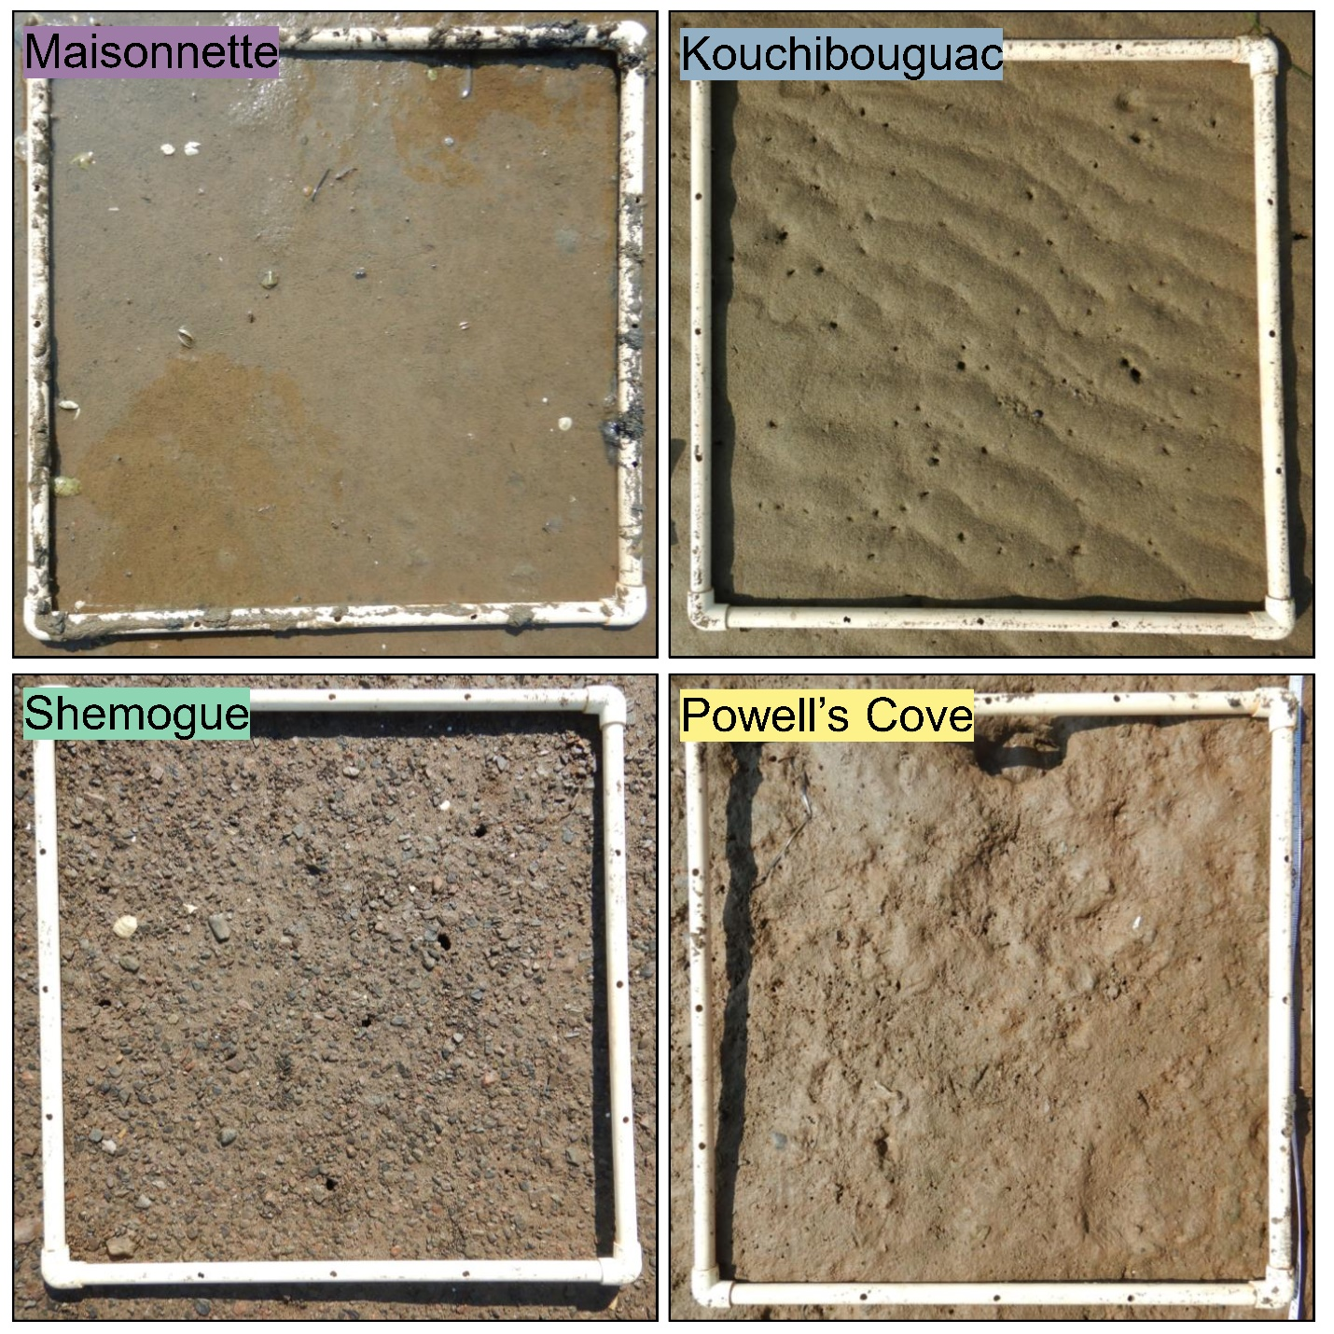
Figure S1. Overhead images of the sediment surface at each of the four study sites.
Figure S2. Temperature (°C) time-series profiles at each of the four study sites. Each point represents the daily mean seawater temperature.
Figure S3. Relationships between siphon hole counts and total clam counts (i.e., clams both above and below 20 mm shell length) at each of the four sites for each observer. The red dashed line represents a 1:1 relationship between siphon hole count and clam count. Open circles represent excluded observations in which methods or conditions deviated from the norm.
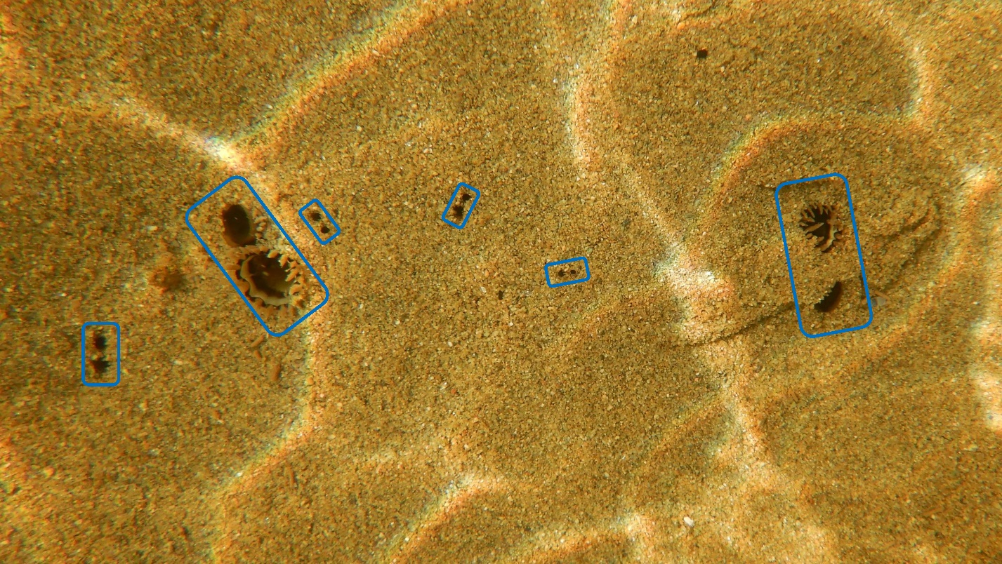
Figure S4. Overhead image of subtidal soft-shell clam siphon holes at the Kouchibouguac site. Visible siphons of individual clams are circled in blue. Note the defined structure of the two siphon channels for each individual clam.
Figure S5. Relationships between siphon hole counts and counts of clams >20 mm at Kouchibouguac, excluding the one large sample. The red dashed line represents a 1:1 relationship between siphon hole count and clam count.
Table S1. Results of ANOVA analysis for the effect of site on sediment grain size composition, % organic content, relative moisture content (%), and seawater temperature on the day of sampling. Bolded p-values denote statistically significant effects. df = degrees of freedom; SS = sum of squares; MS = mean squares.
Sediment grain size
Source of variation | df | SS | MS | F-value | p-value
Site | 3 | 1.53 | 0.51 | 26.46 | 0.0002
Residuals | 8 | 0.15 | 0.02 | – | –
% organic content
Source of variation | df | SS | MS | F-value | p-value
Site | 3 | 0.49 | 0.16 | 1.58 | 0.2686
Residuals | 8 | 0.82 | 0.10 | – | –
Relative moisture content
Source of variation | df | SS | MS | F-value | p-value
Site | 3 | 100.84 | 33.61 | 8.55 | 0.0071
Residuals | 8 | 31.47 | 3.93 | – | –
Water temperature
Source of variation | df | SS | MS | F-value | p-value
Site | 3 | 6034.50 | 2011.49 | 420.52 | <0.0001
Residuals | 1148 | 5491.30 | 4.78 | – | –

Table S2. Tukey HSD contrasts for ANOVA models for the effect of site on sediment grain size composition (phi, φ), relative moisture content (%), and seawater temperature (°C) on the day of sampling. P-values are Bonferroni corrected such that statistical significance is achieved at p ≤ 0.05. Bolded p-values denote statistically significant differences. Note that % organic content is missing because there was no significant effect of site in the ANOVA (Table S1). SE = standard error; df = degrees of freedom.
Sediment grain size
Contrast | Estimate | SE | df | t-ratio | p-value
Maisonnette - Kouchibouguac | 0.64 | 0.11 | 8 | 5.63 | 0.0022
Maisonnette - Powell’s Cove | -0.17 | 0.11 | 8 | -1.48 | 0.4906
Maisonnette - Shemogue | -0.29 | 0.11 | 8 | -2.55 | 0.1261
Kouchibouguac - Powell’s Cove | -0.81 | 0.11 | 8 | -7.11 | 0.0005
Kouchibouguac - Shemogue | -0.93 | 0.11 | 8 | -8.17 | 0.0002
Powell’s Cove - Shemogue | -0.12 | 0.11 | 8 | -1.07 | 0.7180
Relative moisture content
Contrast | Estimate | SE | df | t-ratio | p-value
Maisonnette - Kouchibouguac | 4.56 | 1.62 | 8 | 2.82 | 0.0864
Maisonnette - Powell’s Cove | 7.91 | 1.62 | 8 | 4.89 | 0.0053
Maisonnette - Shemogue | 5.82 | 1.62 | 8 | 3.60 | 0.0289
Kouchibouguac - Powell’s Cove | 3.35 | 1.62 | 8 | 2.07 | 0.2411
Kouchibouguac - Shemogue | 1.26 | 1.62 | 8 | 0.78 | 0.8611
Powell’s Cove - Shemogue | -2.09 | 1.62 | 8 | -1.29 | 0.5939
Temperature
Contrast | Estimate | SE | df | t-ratio | p-value
Maisonnette - Kouchibouguac | 1.47 | 0.18 | 1148.00 | 8.08 | <.0001
Maisonnette - Powell’s Cove | -3.98 | 0.18 | 1148.00 | -21.83 | <.0001
Maisonnette - Shemogue | 1.76 | 0.18 | 1148.00 | 9.65 | <.0001
Kouchibouguac - Powell’s Cove | -5.45 | 0.18 | 1148.00 | -29.91 | <.0001
Kouchibouguac - Shemogue | 0.29 | 0.18 | 1148.00 | 1.58 | 0.3927
Powell’s Cove - Shemogue | 5.74 | 0.18 | 1148.00 | 31.48 | <.0001
Table S3. Tukey HSD contrasts for ANCOVA models for the effect of siphon hole length and site on clam shell length (in mm) and clam weight (in g). P-values are Bonferroni corrected such that statistical significance is achieved at p ≤ 0.05. Bolded p-values denote statistically significant differences. SE = standard error; df = degrees of freedom.
Shell length
Contrast | Estimate | SE | df | t-ratio | p-value
Maisonnette - Kouchibouguac | 0.207 | 2.24 | 192 | 0.093 | 0.9997
Maisonnette - Powell’s Cove | -11.47 | 2.52 | 192 | -4.56 | 0.0001
Maisonnette - Shemogue | -4.434 | 2.24 | 192 | -1.976 | 0.2007
Kouchibouguac - Powell’s Cove | -11.677 | 2.23 | 192 | -5.244 | <.0001
Kouchibouguac - Shemogue | -4.641 | 1.92 | 192 | -2.423 | 0.0761
Powell’s Cove - Shemogue | 7.036 | 2.23 | 192 | 3.15 | 0.0101
Wet weight
Contrast | Estimate | SE | df | t-ratio | p-value
Maisonnette - Kouchibouguac | 0.43 | 1.87 | 192.00 | 0.23 | 0.9956
Maisonnette - Powell’s Cove | -6.28 | 1.88 | 192.00 | -3.35 | 0.0054
Maisonnette - Shemogue | -9.87 | 2.10 | 192.00 | -4.70 | <.0001
Kouchibouguac – Powell’s Cove | -6.71 | 1.60 | 192.00 | -4.20 | 0.0002
Kouchibouguac - Shemogue | -10.30 | 1.86 | 192.00 | -5.54 | <.0001
Powell’s Cove - Shemogue | -3.59 | 1.87 | 192.00 | -1.92 | 0.2213

